The Coshocton County Health Department in partnership with the Coshocton County Sheriff’s Office will be participating in the
NATIONAL DRUG TAKE BACK PROGRAM
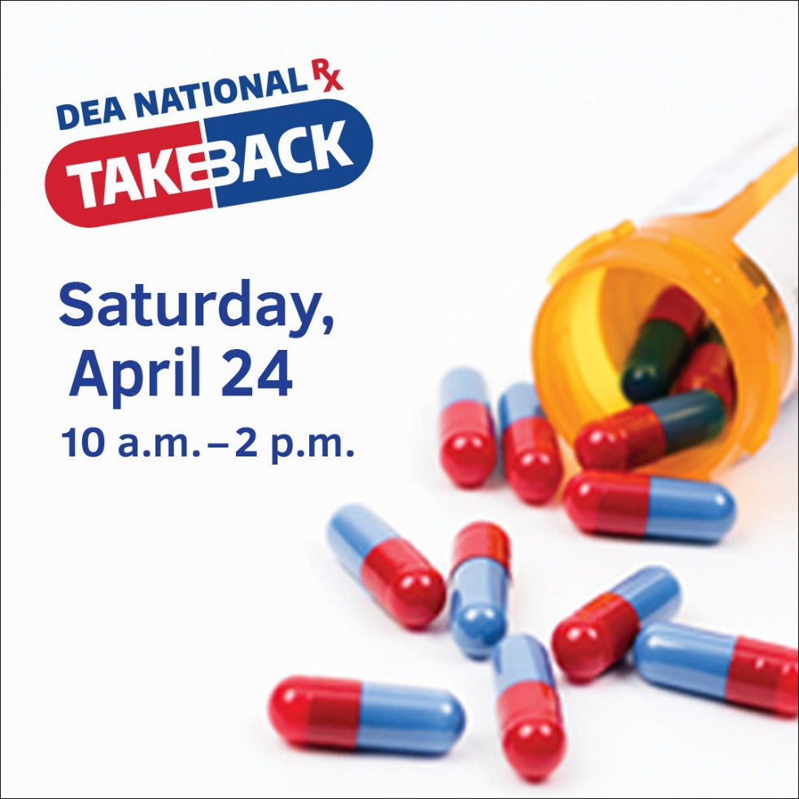
DRIVE THRU DROP OFF
The public can drop off prescription medications at the County Health Department, located at 724 S. 7th Street, Coshocton

