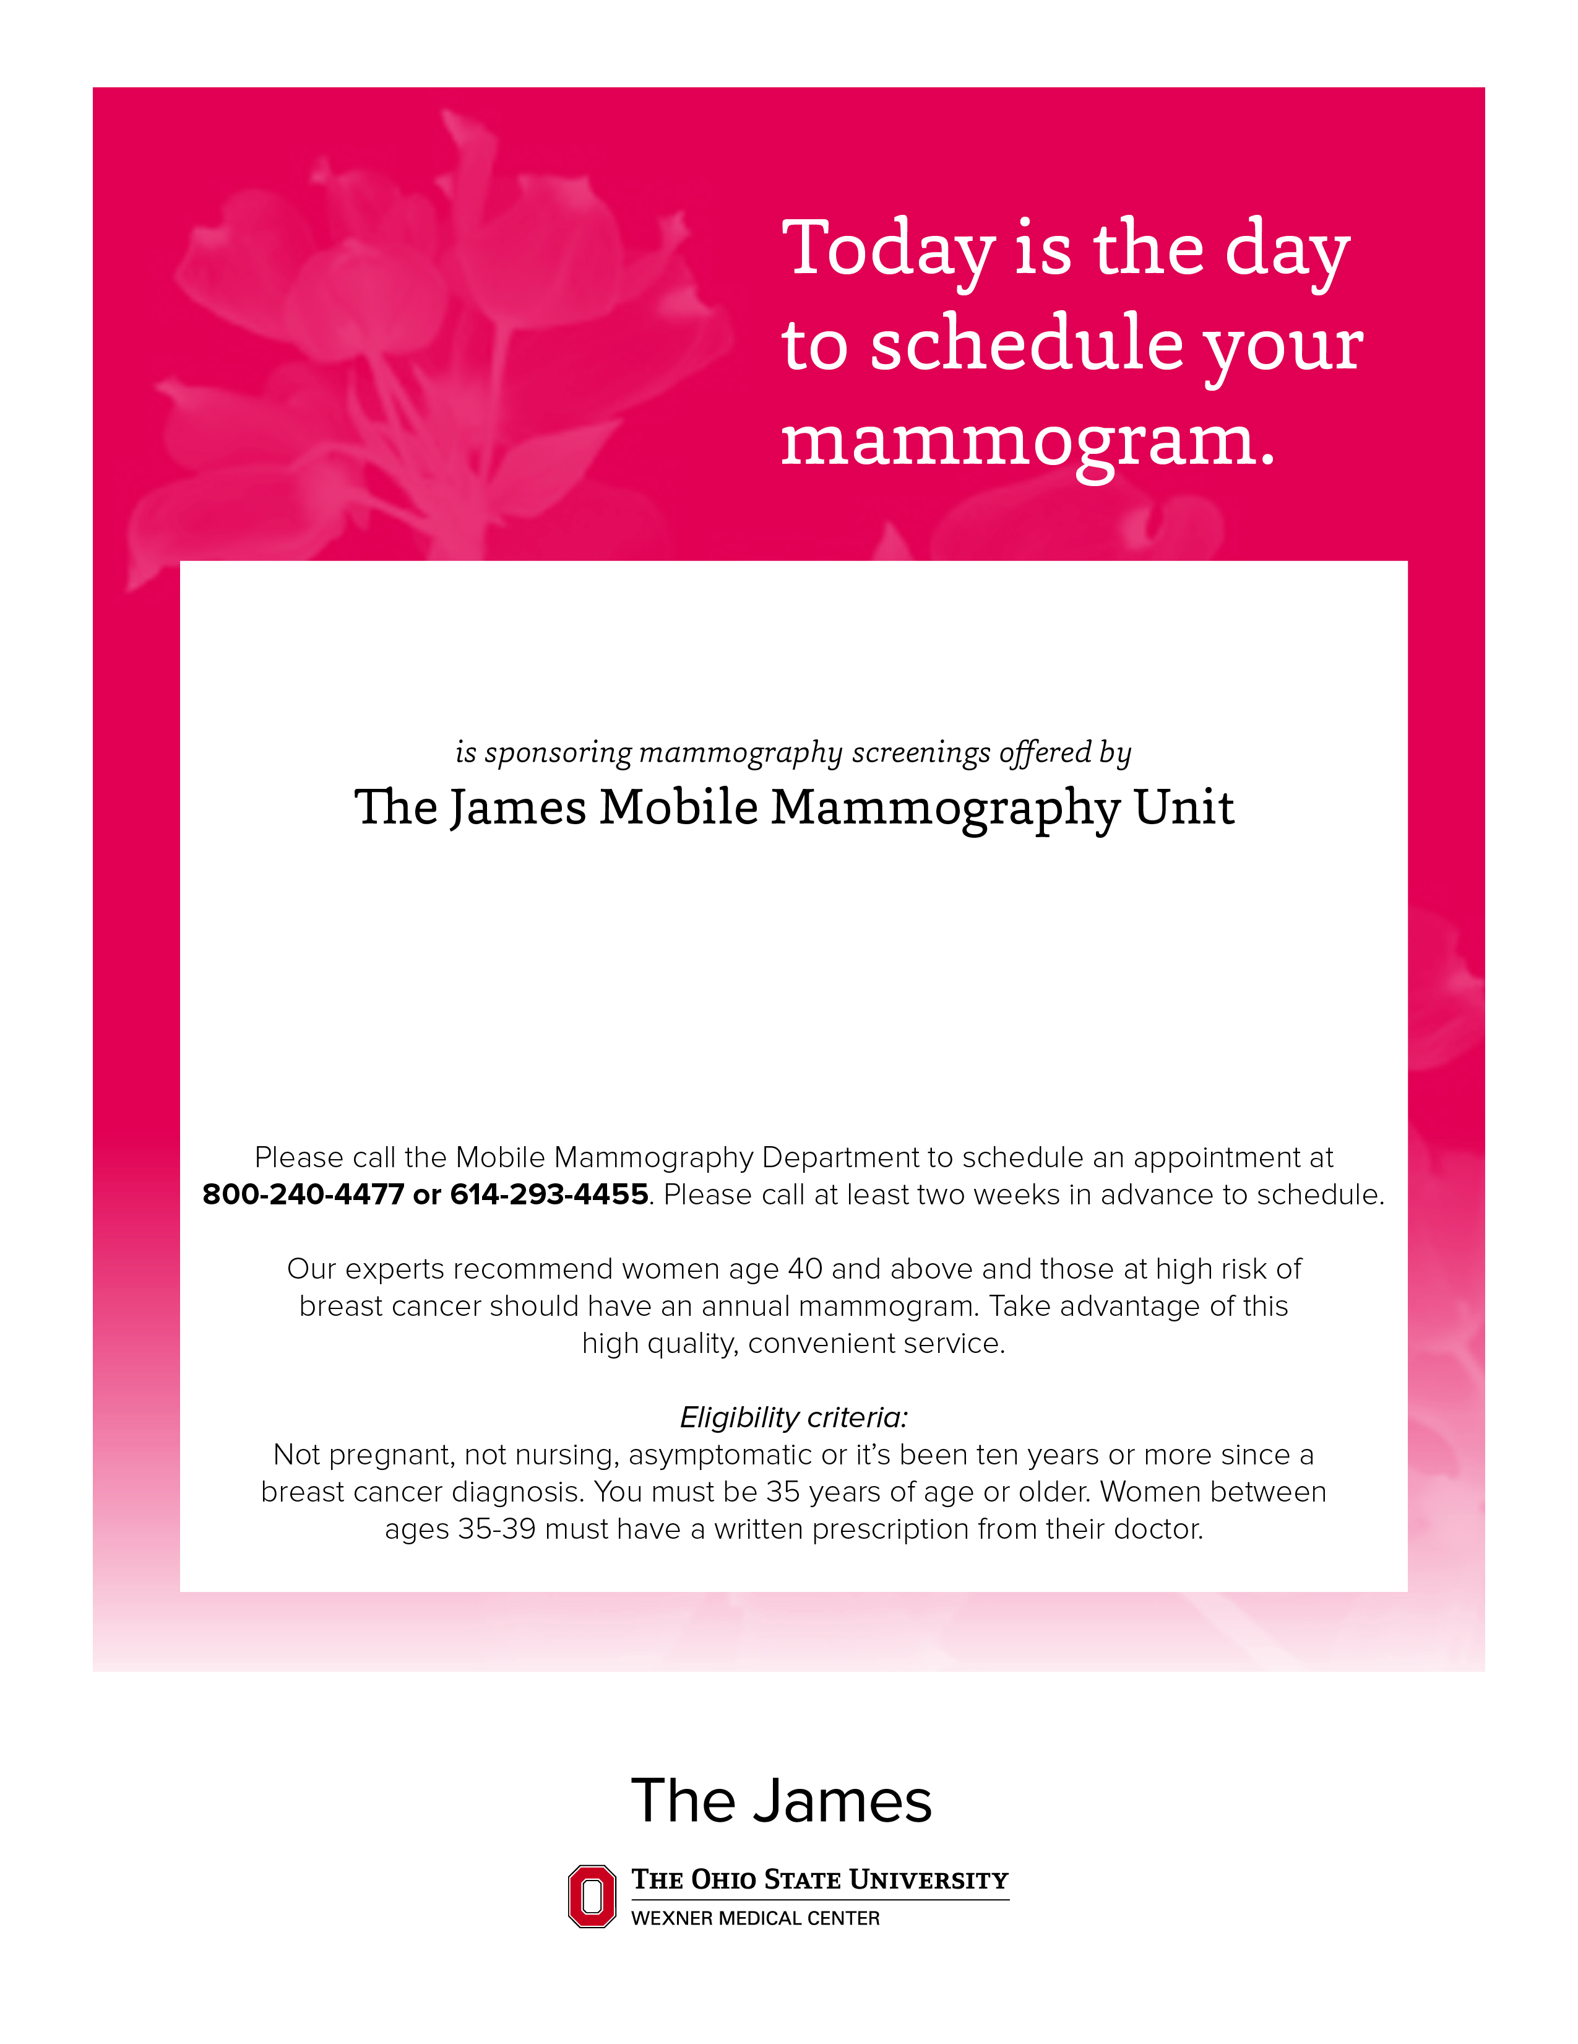

MAY 23, 2018

9:30 AM-3:30 PM

33919 SR 643, New Bedford, OH

NEW BEDFORD COUNTRY STORE